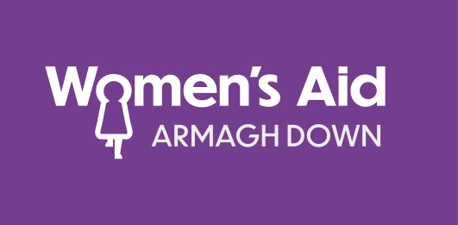

How we process your data?
Within your job application, we will ask you to provide us with personal data. Personal data is information that relates to a living individual who can be identified from the information.
When we ask you for personal data, we promise to:
- only ask for what we need and is relevant;
- make sure you know and understand why we need it, and who we will share it with;
- hold it securely and make sure nobody has access to it who shouldn’t;
- make sure we do not keep it longer than necessary;
- and not make your personal information available for any other use (other than stated on this notice) without your permission unless we are required by law or if you or your child is at risk.

Why do we keep information about you?
- To evidence fair recruitment and selection processes and provide statistical information to the Equality Commission.
How long do we keep your information?
- If you are successful and begin employment with WAAD your information will be held inline with our GDPR Policy.
- If you are unsuccessful within the recruitment process we will retain your data for a period no longer than 12 months after the date of the last interview.
- We retain your Equality Monitoring form for 3 years.

Am I entitled to see the information that is held about me?
You have a right to request access to the information that the organisation holds about you. All requests for information must be submitted in writing. To do this you should write to the Data Protection Officer, 7 Downshire Place Newry BT34 1DZ
If you have any concerns or questions about how we collect, handle or share your information or you wish to make a complaint in this respect you can contact the Data Protection Lead on 028 30250765

