
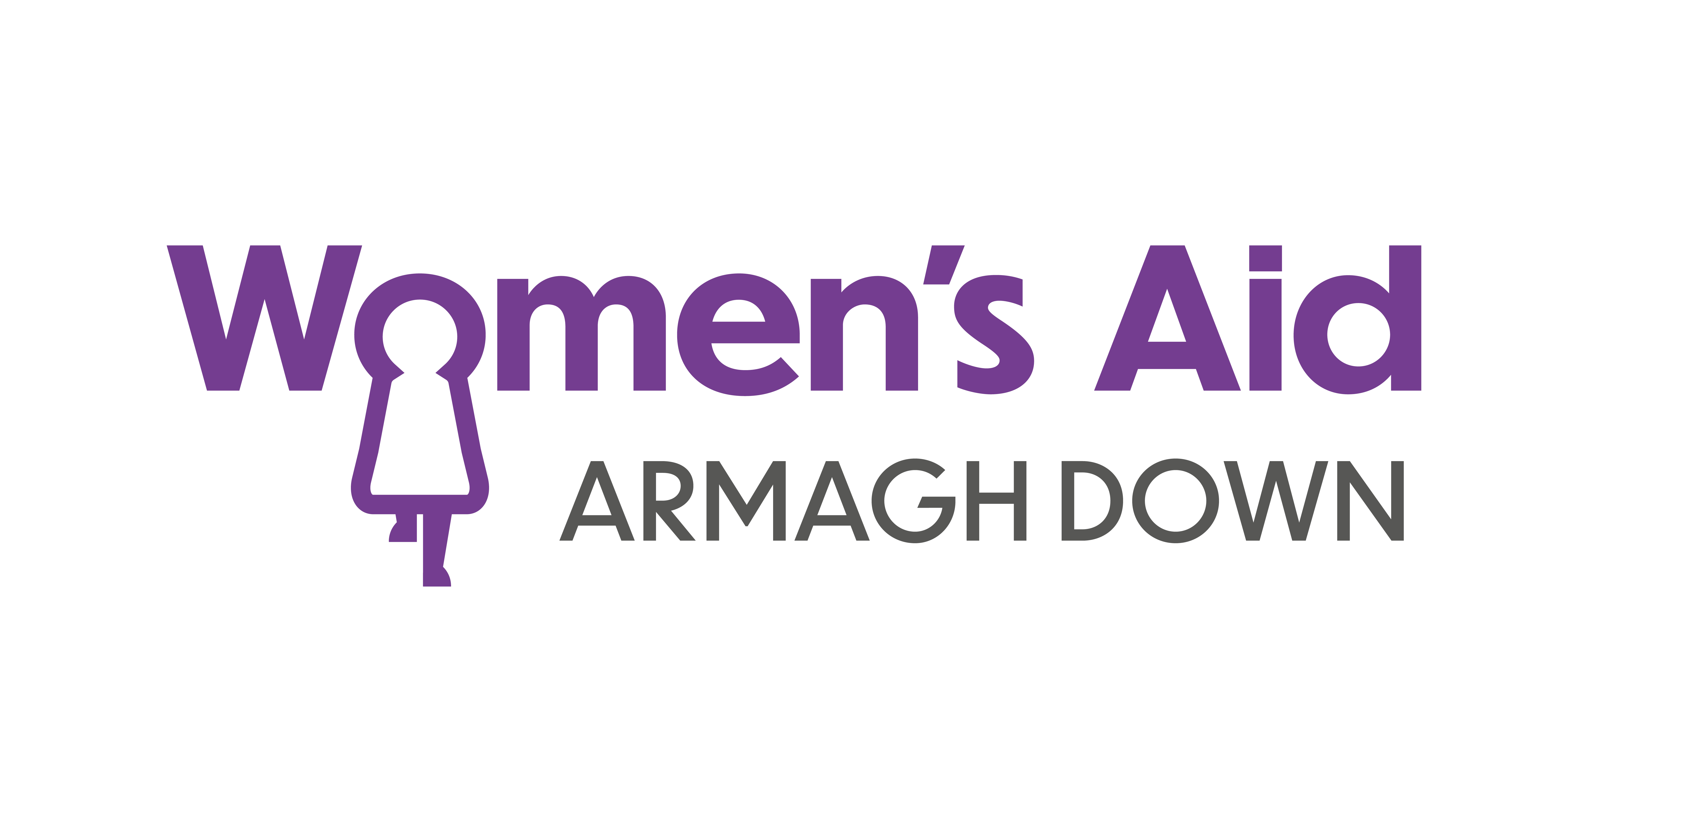

JOB DESCRIPTION & PERSONAL SPECIFICATION Ref: DSASW(SP)/Mar 24

Job Title: | Domestic / Sexual Abuse Support Worker
Accountable To: | Manager / Senior Worker
Responsible For: | Volunteers  Students

JOB LOCATION

Women’s Aid Armaghdown currently has four separate venues from which we provide support services from. Our Refuge provides safe secure crisis accommodation to Women and their children and our Resource Centres provides a wide range of support services to women living in the community.

This post will be predominantly based in our Portadown & Armagh Resource Centre but can be based in any of our venues in as needed.

JOB SUMMARY

- To support and empower women, and their children, using Women’s Aid services who have experienced domestic/sexual abuse and violence (and other forms of violence against them), to make their own decisions. This may involve taking appropriate action to enable them to remain in their own home safely or seeking alternative refuge accommodation.
- To undertake Risk Assessment and Risk Management procedures for all women using our services
- To provide a range of intervention and support processes and programmes for women who have been living with the impact of domestic/sexual violence and abuse.
- To support the Vision and Mission of Women’s Aid in supporting and empowering women and children.
- Provide a quality service that meets Supporting People standards, Safeguarding standards for Children and adults at risk of in need of protection, legal requirements, Women’s Aids’ internal standards / policies and funder’s requirements.
- To work with a wide range of women who may have complex needs.
- To take all possible steps to ensure the safety, confidentiality, data protection and reduction of risk of the service users, staff and management of Women’s Aid.

KEY RESPONSIBILITIES

  - DUTIES:

  - To ensure referrals for support meet the remit of Women’s Aid services.

  - To welcome and integrate women, children & young people into Women’s Aid service

  - To comply with all health and safety procedures within the work place and ensure that all service users are aware of their responsibilities.

  - To comply with all safeguarding measures and to ensure the completion and safe delivery of DASH RIC forms, MARAC referrals and UNOCINI’s and APP1’s

  - Assist in the induction and training of new team members including volunteers and student placement when required.

  - Participate fully in department meetings with staff and volunteers.

  - To liaise with and act as an advocate on behalf of service users with external agencies.

  - To maintain good public relationships between and with relevant voluntary and statutory agencies and liaise as appropriate.

  - To assist service users to apply for / maintain / maximise benefits and manage other financial issues.

  - To assist in the implementation, monitoring and review of all service delivery for quality assurance systems.

  - To promote the best interests of women children and young people at all times.

- SUPPORT SERVICES TO WOMEN

  - To assess the level of risk to and from women referred to women’s aid service

  - To ensure an effective risk management plan is implemented when risk is identified

  - To provide information on accessing alternative services to any women not admitted to our service.

  - To provide one to one support for women who are living with the impact of Domestic/ Sexual violence and abuse mindful of complex needs and potential dual diagnosis.

  - To provide practical and emotional support to women in their dealings with external agencies.

  - To identify the needs of women contacting Women’s Aid for support, ensuring their needs are adequately addressed.

  - To develop relevant support programmes for women in line with the aims and objectives of the Womens Aid Domestic / Sexual Violence Intervention Service.

  - To identify issues of concern to women and create and develop opportunities for discussion and group work.

  - To work in close collaboration with the full team within women’s aid ensuring clear and effective communication and organisation of service delivery.

  - To work in close collaboration with the full team within women’s aid to avail of all opportunities available to women and children

  - Ensure women accessing the service receive appropriate and accurate information including advice about their rights and that all relevant records are maintained.

2.11 Carry out needs assessments and develop support and safety plans with agreed objectives, time scales and review periods. This must be carried out within Supporting People QAF requirements.

2.12 Liaise and advocate on behalf of service users with external agencies, encouraging and supporting self-advocacy as appropriate. This may involve accompanying women to appointments with community groups and statutory agencies including social services, police and housing executive.

2.13 Offer on-going support to women with regard to court services and solicitors, etc.

2.14 Offer enhanced support to women and children with specific needs e.g. cultural, mental health, alcohol and drugs, learning difficulties; through consultation with managers and other support workers or referring to external agencies.

2.15 Support and empower women to identify personal needs and goals to promote their personal development through the encouragement of participation in all appropriate areas of service provision.

2.16 To keep up-to-date with changes in legislation and working practices and ensure Women’s Aid standards and Women’s Aid requirements are met at all times.

2.17 To be fully aware of the child and adult safeguarding and protection procedures in Women’s Aid and report to your line manager any concerns or issues in this area.

2.18 Promote women’s aid’s self-help ethos and encourage women to support each other and learn through shared experiences.

- HEALTH & SAFETY

  - To adhere to Women’s Aid Health & Safety policy and report any risks/concerns to the, designated Health & Safety officer taking immediate steps where necessary to protect the health and well- being of residents, team members and members of the public.

  - To work jointly with the designated Health & Safety officer to ensure safe and effective management of all women’s aids premises.

  - Undertake regular risk assessments to ensure safe working practices and safety of all resources and people are maintained.

  - To take shared responsibility to ensure that essential repairs at Women’s Aid premises are carried out.

  - To ensure service users are aware of their responsibilities in relation to Health & Safety and promote the concept of service users being fully engaged with the Health & Safety requirements and activities within women’s aid.

  - To take part in housing management tasks as required i.e. room preparation, managing breaches of licence and reporting any maintenance issues. This includes making sure rooms at refuge are ready and any other domestic duties from time to time in any of Women’s Aid venues.

  - To have a clear understanding and to work within the organisation’s Lone Worker policy.

4.0 PROMOTING THE WORK OF WOMEN’S AID

4.1 Collaboratively assist women’s aid team to raise awareness of domestic and sexual violence within the local and wider community.

4.2 Help develop positive working relationships with key partner agencies and stakeholders to achieve better outcomes for women and children affected by domestic / sexual abuse and violence

4.3 Promote volunteering within Women’s Aid and assist in the development of volunteering opportunities within your team through guidance and support.

4.4 Support the promotion of Women’s Aid’s public and media profile through participation in training, talks, presentations and multi-agency forums when requested.

4.5 When required, to represent the organisation at external meetings, public events, conferences and similar ensuring that Women’s Aid’s reputation is protected and enhanced.

5.0 INTERNAL

5.1 To have a clear understanding of, and to work within, the policies, standards and procedures required by the law, Women’s Aid, and funders.

5.2 To help create and share an understanding of the policies, standards and procedures required by law, Women’s Aid and funders with new members of staff, volunteers and placement students.

5.3 Assist with the development, monitoring and evaluation of the work of Women’s Aid through accurate information recording and maintaining monitoring systems.

5.4 To take responsibility for supporting all aspects of the management and administrative of the organisation.

  - To deal with correspondence, produce written reports when required and be self servicing.

5.6 Participate in team meetings, supervision and appropriate training in agreement with the Senior Management Team and the CEO.

5.7 Fully engage with all rota duties including late evenings, weekend and bank holidays rota requirements

- WORKING APPROACH

  - Demonstrate and promote the organisation’s ethos of informed choice, and its vision, values and feminist principles.

  - Work collaboratively and assist, as appropriate, other Women’s Aid workers. This includes regularly attending team meetings, supervision, appropriate training, other relevant meetings and keeping colleagues up to date on relevant work issues. Ensuring that decisions regarding the work of Women’s Aid are followed up.

  - Maintain clear and accurate records of work done and in progress, ensuring they are accessible to other staff.

  - Provide support in the induction and training of new team members and volunteers as required.

  - Support aspects of volunteer recruitment as required.

  - To give support to other workers (including support workers in refuge, outreach and C&YP projects) during busy periods of staff shortage, as and when necessary, including working unsociable hours.

  - Support the CEO, senior management and Directors in creating a continuously improving organisation focused on service users.

  - To carry out any other task that might be required from time to time in the interest of the effective running of the organisation.

7.0 EQUAL OPPORTUNITIES STATEMENT
7.1 Take a proactive role in promoting Women’s Aid equality and anti-discriminatory policies throughout all aspects of the work.
7.2 To ensure the complexity of different needs faced by all service users are recognised appropriately.
8.0 DATA PROTECTION & FREEDOM OF INFORMATION

8.1 To ensure that compliance with current law regulation and best practice in respect of data protection and freedom of information for manual and computerised records in accordance with the organisations policies and procedures.
9.0 FLEXIBILITY STATEMENT
9.1 Be flexible and responsive to project needs by being available to work evenings and weekends on a rota basis.

9.2 It may be necessary, following consultation, to amend the job description in light of experience and changing circumstances.

9.3 To attend meetings and training days as required

9.4 To participate in fundraising activities as required

9.5 This job description cannot cover every issue or task that may arise within the scope of the post. The post-holder will be expected to carry out other duties from time to time which are broadly consistent with the duties detailed above.

10 SUBJECT TO:

10.1 This post is subject to satisfactory Access NI / Enhanced Disclosure checks.

10.2 This post is also subject to the receipt of two satisfactory references.

10.3 Please note: A criminal record will not necessarily be a bar to obtaining a position in Women’s Aid Armaghdown.

TERM: 2 Year fixed term contract (subject to funding with possibility of extension)

HOURS: This post is open to negotiated contract hours:

- 37.5hrs (over 5 days)

- 30hrs (over 4 or 5 days)

- 22.5hrs (over 3 days)

SALARY: Year one: £25,545 (equal to £13.10/hr) & Year two: £26,421(equal to £13.55/hr)

pro rata (subject to funding)

Additional staff benefits – see website www.womensaidarmaghdown.org

Personnel Specification
ESSENTIAL
Qualifications & Experience | - 1 years’ experience in the direct one to one ongoing support of people in crisis in both a practical and emotional role & an academic qualification at level four or above (e.g. HNC, NVQ) in a relevant field.  OR  2 years’ experience in the direct one to one ongoing support of people in crisis in both a practical and emotional role
Experience & Skills  Skills | - Experience in the identification and assessment of risk & associated safeguarding practices.
Experience & Skills  Skills | - Experience in the development and implementation of person-centered support plans and management of a key worker case load.
Experience & Skills  Skills | - Competent in the use of IT systems (including Microsoft).
Other | - Car driver with access to a car.
DESIRABLE
- Strong communication skills – verbal and written and the ability to give competent presentations, and facilitate group discussions.
- Proven ability to understand and adhere to Health & Safety at work.
- Ability to effectively plan and organise own workload and coordinate other resources to meet deadlines.
- Excellent team working skills.
- A high degree of personal motivation and a willingness to learn new skills take on challenges and undertake relevant training.
- Commitment to the Vision, Mission and Ethos of Women’s Aid Armaghdown.

