  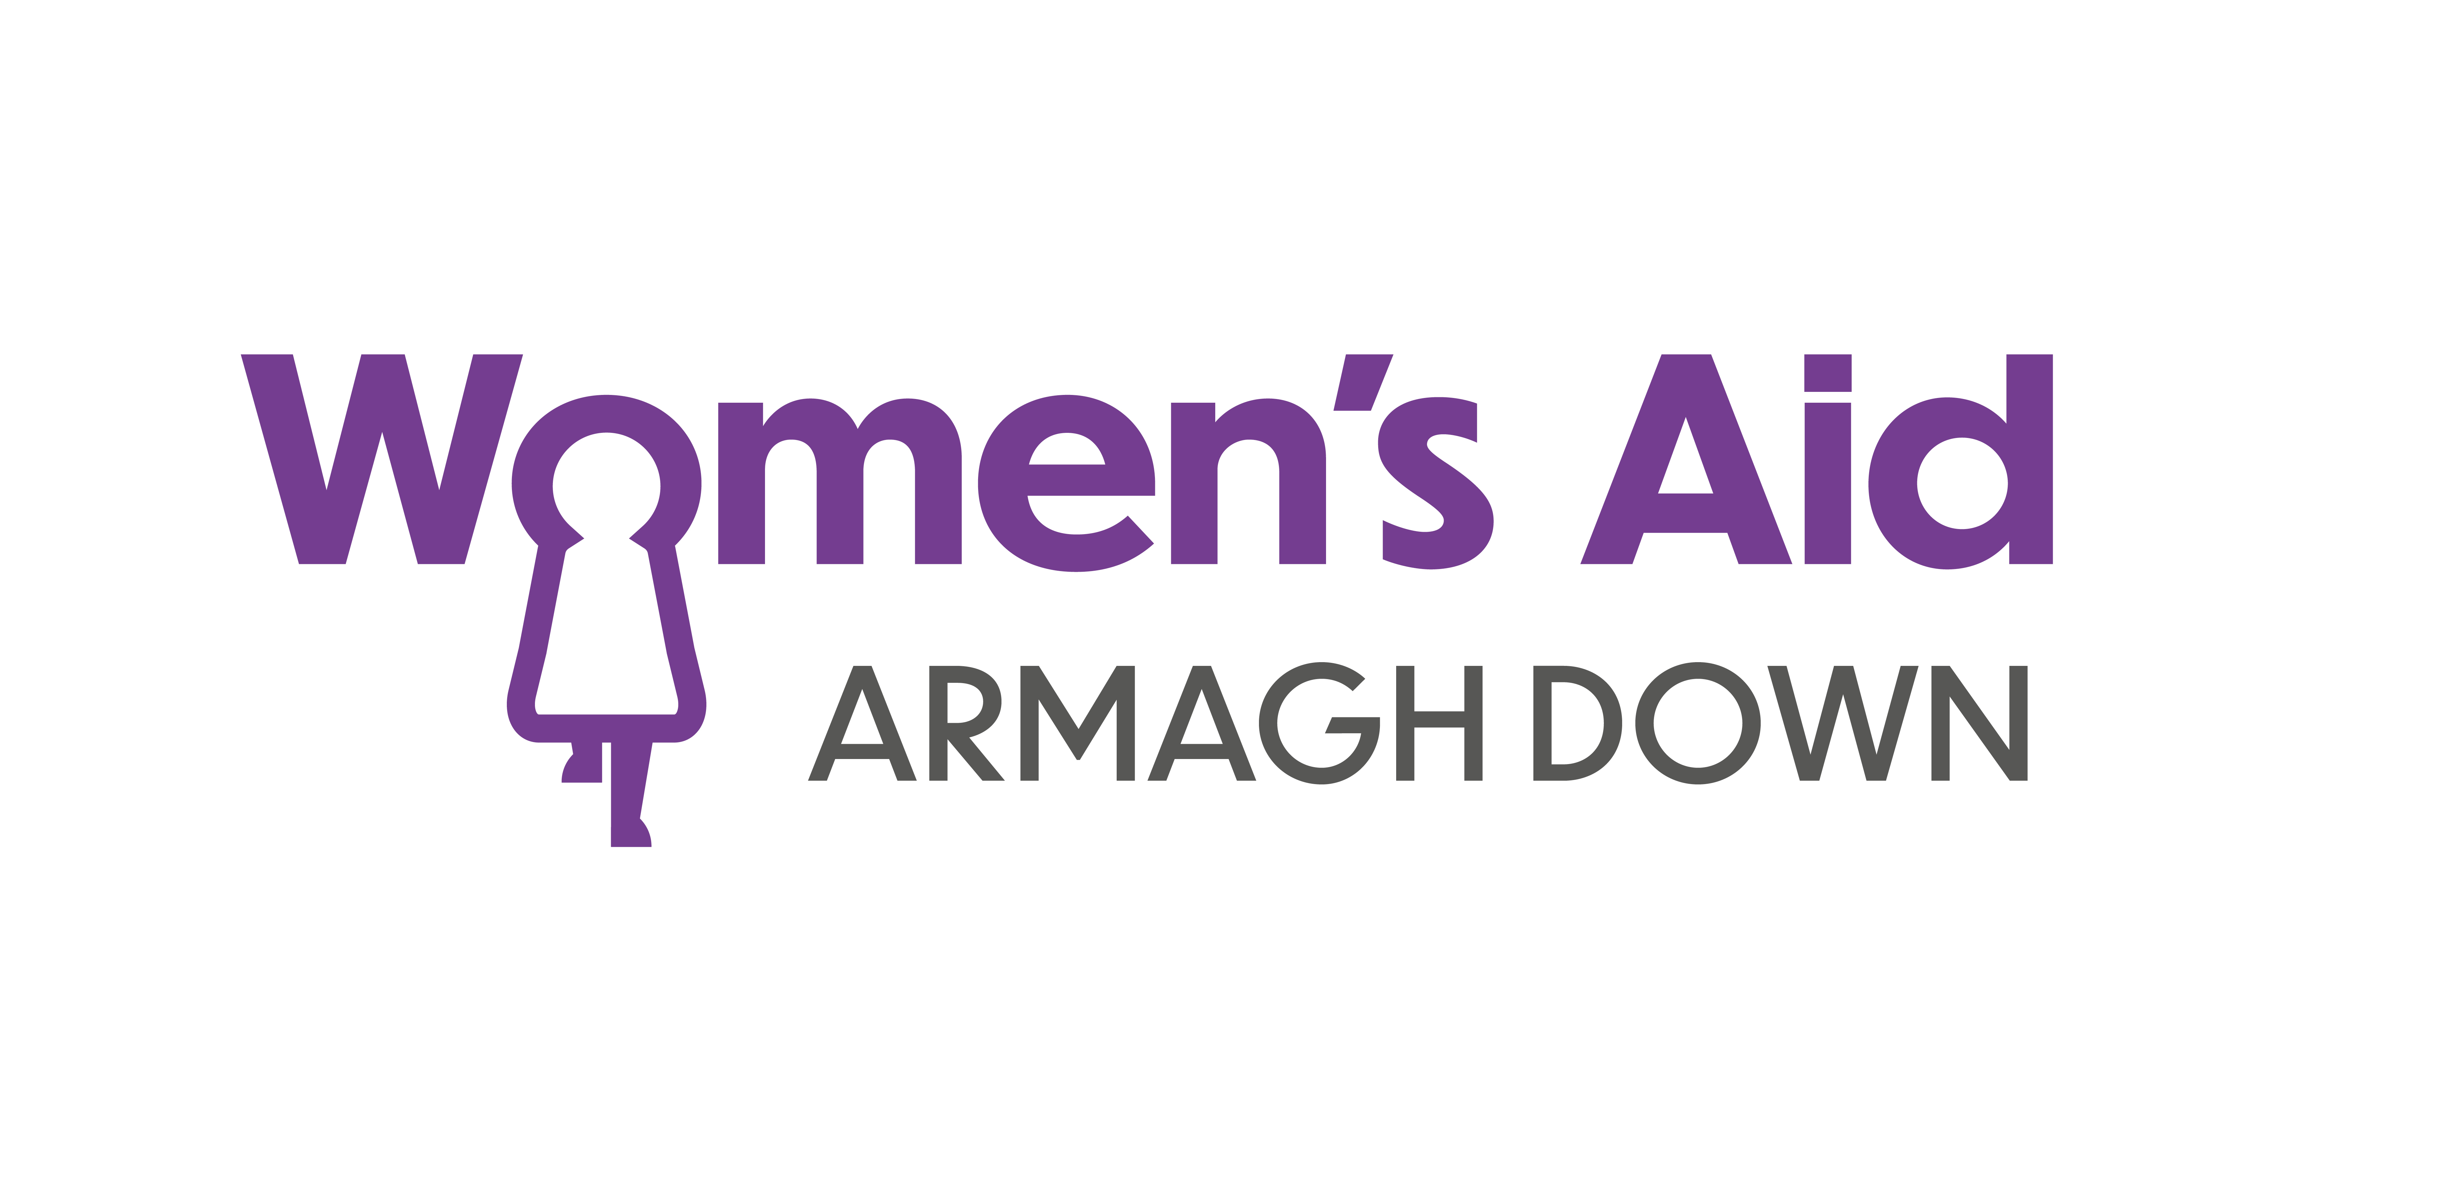 |  | 
Application for post of | Domestic / Sexual Abuse Support Worker
Post reference | Ref: DSASW(NW)/Mar 24D-J17D/ SVSW/PD-J17
Closing date: | Wednesday 3rd April @ 8pm  Successful shortlisted candidates will be notified by Tuesday 9th April  Interviews will be held week beginning Monday 15th April

1 Contact details
Title |  |  | First name |  |  |  |  |  |  | Surname
Address
Town |  |  |  |  |  |  |  |  |  |  | Postcode
Home contact number |  |  |  |  |  |  |  |  |  | Mobile
Email address
National Insurance number

2 References
You must give the names and addresses of two referees, one of whom should be your current or most recent employer. Relatives and friends should not be nominated as referees.

Current / Most recent employer |  |  |  | Other referee
Name |  |  |  | Name
Email |  |  |  | Email
Telephone |  |  |  | Telephone
Status/position |  |  |  | Status/position
Relationship |  |  |  | Relationship

3 Current Employment

Name & employer

Address of employer

Title of post held
Date appointed to post |  | Date of leaving post (if applicable)
 |  |  | Notice period

Duties of the post (briefly):

4 Employment history – Start with the most current
Employer name and address | Job Title | Brief outline of duties | Dates of employment |  | Reason for leaving
 |  |  | From | To

RELEVANT EXPERIENCE TO THIS POST
Explain below how you meet all of the Essential Criteria listed on the Personnel Specification, ensuring you give clear evidence based professional work examples.

Please Note: The word count for each Essential Criteria should not exceed 200 words per criteria.

Shortlisting will be based on the evidence that you supply on your application form to satisfactorily demonstrate how, and to what extent, you meet the criteria. The Shortlisting Panel will not make assumptions as to your circumstances, qualifications, and experience.
Essential criterion 1:
Qualifications & Experience
1 years’ experience in the direct one to one ongoing support of people in crisis in both a practical and emotional role & an academic qualification at level four or above (e.g. HNC, NVQ) in a relevant field.
OR
2 years’ experience in the direct one to one ongoing support of people in crisis in both a practical and emotional role.
Essential criterion 2:
Experience and Skills
Experience in the identification and assessment of risk & associated safeguarding practices.
Essential criterion 3:
Experience and Skills
Experience in the development and implementation of person-centered support plans and management of a key worker case load.
Essential criterion 4:
Skills
Competent in the use of IT systems (including Microsoft).
Essential criterion 5:
Other
Car driver with access to a car
Desirable criterion
Please also demonstrate where appropriate how you meet the Desirable Criteria as this may also be used to shortlist for interview.

Please Note: The word count for this section should not exceed 300 words in total.

Compulsory Declaration 1: by the applicant
I declare I do not know of any reason why I cannot work in regulated activity. I accept that providing false information or suppressing any information wilfully will make me liable to disqualification, and if appointed, to dismissal.

Signature:______________________________________ Date:___________________

Compulsory Declaration 2: by the applicant
I declare I have not canvassed in any way and that the information in this application is complete and correct to the best of my knowledge. I accept that providing false information or suppressing any information wilfully will make me liable to disqualification, and if appointed, to dismissal.

Signature:______________________________________ Date:___________________

Please Note: A Criminal Record will not necessarily be a bar to obtaining a position in Women’s Aid Armaghdown.
Women's Aid is a woman only organisation and the lawful recruitment of females for this post falls within exemption stated in Article 10 (2 b&e) of the Sex Discrimination (NI) Order 1976

THANK YOU FOR COMPLETING THIS APPLICATION FORM.
PLEASE RETURN IT TO:
rebekah@womensaidarmaghdown.org

Please note
The interviews will be held in our Women’s Resource Centre at 53 William Street, Portadown.

If you are successful in the shortlisting process you will be contacted with your allocated interview time.

